**Project Log Book**

**Group Members:**

|  |  |
| --- | --- |
| **Entry Date** | **Work Done** |
| October 10th, 2021 | Discussed the basic plan to build the prototype for CRM on google meet, noting down all constraints to be taken care of. Furthermore, we decided our next group meeting would be on October 12th, 2021 (Tuesday) at 8:00 PM, meeting place: Google meet. |
| October 12th, 2021 | Meeting on Google Meet: We discussed about the project objective. Using the Software Management Plan template printed from the web site, we stepped through each section and discussed what was required and what resources were available to us. |
| October 16th, 2021 | Finished a prototype form and submitted it on the Online Platform(LMS). |
|  |  |
|  |  |
|  |  |
|  |  |
|  |  |
|  |  |
|  |  |
|  |  |
|  |  |

***Last Updated on October 27th, 2021***

**Software Requirements Specification**

*for*

***Photos Buy and Selling System***

***(Exposure.com)***

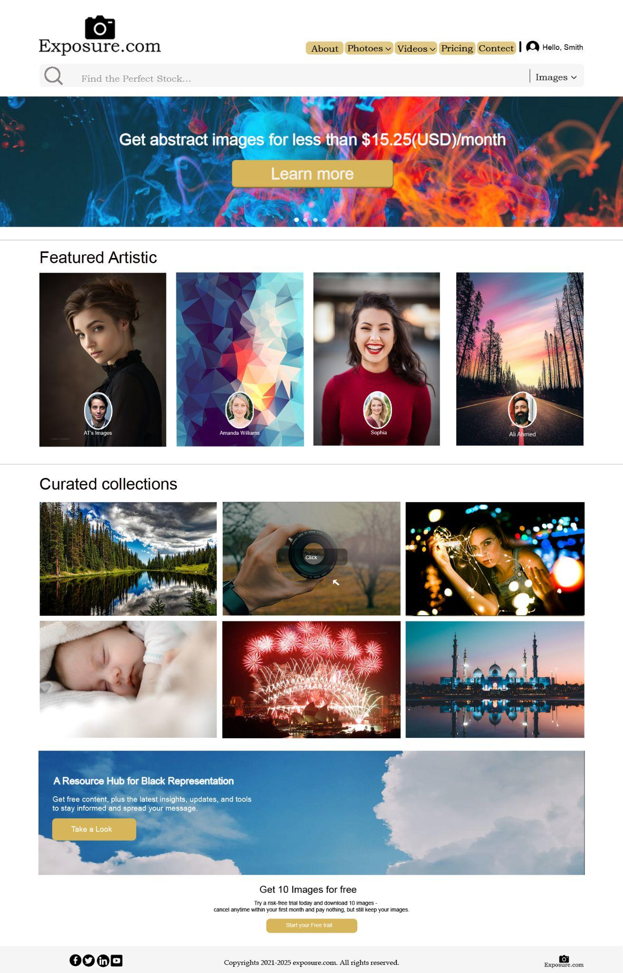

***Imad Bin Jawed (62604)***

**Mehmood (11097)**

**Yousuf Baloch (11495)**

***October 19, 2021***

|  |  |  |
| --- | --- | --- |
| Version | Changes Made | Date |
| 1.0 | [First Pass for Review](http://www.geocities.com/cs5391/SRS1.htm) | 10/16/2021 |
| 1.2 | [Second Pass for Review](http://www.geocities.com/cs5391/SRS2.htm) | 10/25/2021 |
| 1.3 | [Third Pass for Review](http://www.geocities.com/cs5391/SRS3.htm) |  |
| 1.4 | CRM Review Version |  |
|  | | |

**Table of Contents**

1. Introduction

2. The General Description

3. Specific Requirements

4. Supporting Information

**1. Introduction**

**1.1 Purpose**

This document describes the software requirements for the Photos buying and selling system.

**1.2  Scope In**

The ***exposure.com*** is a requesting proposals to build a prototype of the Photos buying and selling system (PB&SS) for their current system. This new (PB&SS) needs to be scalable enough so that it can accommodate the buying and selling process.

The system will be designed to provide a plate form that a user can buying and selling their stock photographs. The system will have a user-friendly graphical interface and will be more cost effective for the buyer and seller.

The **objectives** of this development effort are:

1. In this view, a customer can register as a member Free or based on some packages that will be available and buy the Photos that they want.
2. They can purchase one picture if they don’t want to buy bulk picture packages.
3. They can purchase monthly or yearly based packages for downloading some counts of the pictures and the videos. But these will be only applied for those pictures and videos their pricing will not be mentioned by the seller
4. They can set their own price of the Photos if they want or sell it through a website pricing policy.

**1.3  Scope Out**

The following features will not be the part of this Project:

1. Admin view that calculates the markup of the site owner. This will be done in the next phase.

**1.3 Definitions, Acronyms, and Abbreviations.**

PB&SS – Photos Buying and Selling System

EDC – Exposure.com

PP - Project Plan

SDD - Software Design Description

SRS - Software Requirement Specification

SDS – Software Design Specification

SPMP - Software Project Management Plan

GUI – Graphical User Interface

QAM – Quality Assurance Manager

PDM – Project Development Manager

PMP – Project Management Professional

TBD – To be determined

UML – Unified Modeling Language

**1.4 References**

∙       Shutterstock: https://www.shutterstock.com/

**1.5 Overview**

Chapter 2 of the SRS is a brief description of the characteristics of the software to be built, its functions, its users, its constraints and its dependencies.

Chapter 3 is about specific requirements, such as functional requirements, external interface requirements, performance requirements, and also design constraints and quality characteristics.

Finally, chapter 4 includes all the supporting information, such as the Table of Contents, the Appendices, and the Index.

**2. The General Description**

This section describes the general factors that affect the product and its requirements. This section consists of five subsections that follow. This section does not state specific requirements. Each of the subsections makes those requirements easier to understand, it does not specify design or express specific requirements. Such detail is provided in section 3.

**2.1 Product Perspective**

The Photos Buying and Selling System’s diagram showing the overview of the system’s modules and the relationship of the system to external interfaces is presented in Figure 2.1.

## Figure 2.1 Overview/Architecture Diagram of the PB&SS

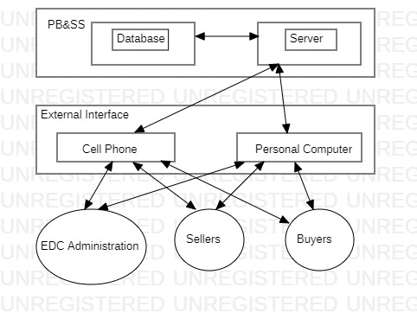

**Functions of System Components:**

Database:

∙       Stores data

∙       Creates reports

∙       Provides access to data

∙       Updates information

Server:

∙       Provides access to the database

∙       Authenticates users

∙       Processes reservations

∙       Performs backups

∙       Produces reports

**External Interfaces:**

Personal Computers

∙       Users (Buyers, Sellers and website(exposure.com) administration) may use personal computers to obtain a remote access to the interface of the exposure.com website via the Internet.

Cell Phones

∙      Exposure.com client will access this application on their cell phones and they can upload and download images on that medium as well.

**2.2 Product Functions**

This section provides a summary of the functions that the software will perform.

**2.2.1 Function Relationships**

Figure 2.2 to 2.6 depict the relationships among the functions to be implemented by the system.  
  
Figure 2.2 P General Function Relationship/**Higher Level Usecase** Diagram

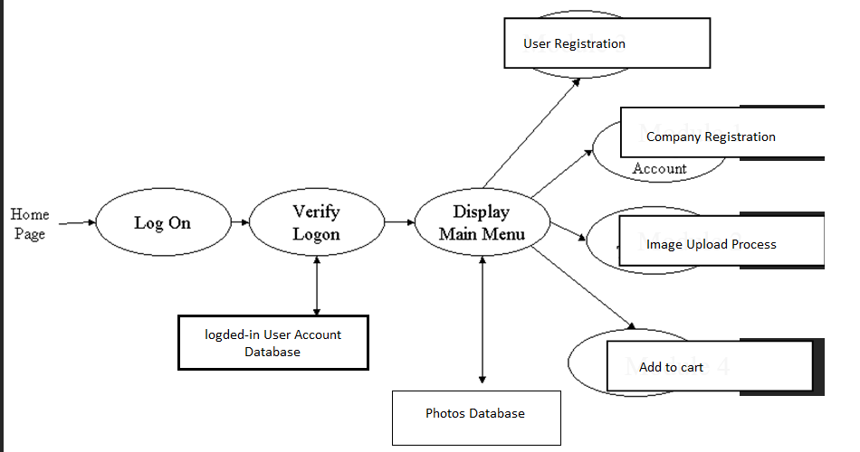

**2.2.2 Function Descriptions (Functional Requirement Listings)**

**2.2.2.1 Log In Function**

***Description:*** This function ensures that only authorized users gain access to the Reservation databases. An authorized user is a user who has an account on the system. Users include passengers, train officials, and CRM ministry officials. The user must type a valid username and password to gain access.

**2.2.2 Module 2: User Registration Process:**

***Description:*** This function allows the user to Register yourself with as a seller or a buyer.

If the user does not already have a account on exposure.com, then they cannot access this website.

**2.2.3 Module 3: Company Registration Process:**

***Description:*** Basically this function is used for Client/User Company Registration by itself and some Credential fill like payment and Content Information.

**2.2.4 Module 4: Image Uploading and Processing:**

***Description:*** This function will help the user to upload the image which user captures and want to sell his client to generate income.

**2.3 User Characteristics**

The main users of the system will be the buyer and the seller that will upload or download photos, and the EDC administration that access the reports generated by the system.

**2.4 General Constraints**

The constraints for the project are:

* The functional prototype should be available after 30 days.
* This may prove to be a serious time constraint on the development of a successful prototype.
* All team members work on the Module part must be done by each member and then finally merged by the Group Leader for a Single merged submission.

**2.5 Assumptions and Dependencies** **or Business Logic**

The assumptions for the project are:

* In this project we will create a web-site that will be used for buying and selling the Photos that clients want. Also, this site will provide the platform for those photographers to sell their photos and videos for earning purposes.
  + In this project we have three aspects that are mentioned in the following.
    - Site Holder
    - Buyer or Member
    - Contributor
* This site will provide the platform for those photographers they can sale its photos for earning purpose and the site holder will get some percentage amount from the seller income.
* The site holder can also earn revenue through selling the packages to the buyers
* In this view, a customer can register as a member Free or based on some packages that will be available and buy the Photos that they want.
* They can purchase one picture if they don’t want to buying bulk picture packages.
* They can purchase monthly or yearly based packages for download some counts of the pictures. But these will be only applied for those pictures whose pricing will not be mentioned by the seller.
* In this View, a seller can register as a member Free and will upload their stock photos and videos for selling purpose and earn money for its own stocks.They can set their own price of the Photos if they want or sell it through website pricing policy.

**3. Specific Requirements**

This section of the SRS contains design requirements for the Photos Buying and Selling System

**3.1 Functional Requirements**

**3.1.1 Log In Function**

1. ***Description:*** This function ensures that only authorized users gain access to the EDC domain. An authorized user is a user who has an account on the system. The user must type a valid username and password to gain access.

1. ***Usage Scenario/ Use case Description/******Specification:***

|  |  |
| --- | --- |
| Description | Allows access to online PB&SS |
| Inputs | Username, password |
| Source | 1. User inputs username and password 2. Press Login Button |
| Alternate case |  |
| Outputs | Successful login; unsuccessful login |
| Destination | None |
| Precondition | Authorized User |
| Post Condition | No change to Logged-in User Accounts Database |
| Side Effects | Failures and successful logins are sent to EDC Database |

1. ***Detailed Use Case Diagram for Login: optional***

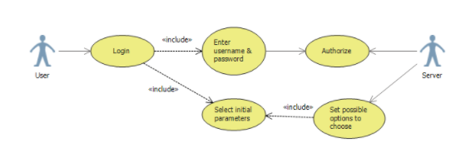

1. ***Use case Realization for Login: optional***
2. ***Flow of Event or Data Flow Diagram for Login: optional***

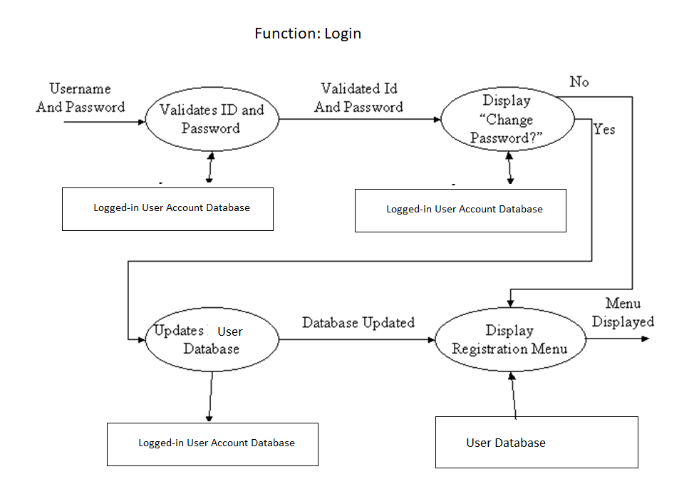

1. ***Sequence Diagram for Login: optional***
2. ***Collaboration Diagram for Login: optional***
3. ***Activity Diagram for Login: optional***
4. ***Class Diagram for Login: optional***
5. ***State Chart Diagram for Login: optional***
   * 1. **Module 1 complete CRUD User Registration Process:**

1. ***Description:***
2. ***Usage Scenario/ Use case Description/******Specification:***

|  |  |
| --- | --- |
| Description | [ make | drop | view | update] a reservation to the user’s account |
| Inputs | From city, to city, seat type, travel date, return date and time |
| Source | 1. User inputs from city, to city, seat type, travel date, return date and time 2. Press Button … |
| Alternate Case |  |
| Outputs | Added | Deleted | Viewed | Modified reservation |
| Destination | Computer screen  Reservation database  Passenger Account database |
| Precondition | Valid information; train route and tickets available; user does not have another reservation at the same time |
| Post Condition | Reservation added to passenger account |
| Side Effects | User’s current reservations adjusted  Balance due adjusted |

1. ***Use case Diagram:***
2. ***Use case Realization:***
3. ***Flow of Event or Data Flow Diagram:***
4. ***Sequence Diagram:***
5. ***Collaboration Diagram:***
6. ***Activity Diagram:***
7. ***Class Diagram:***
8. ***State Chart Diagram:***

**3.1.3 Module 3 complete CRUD Company Registration Process:**

***Use case Diagram:***

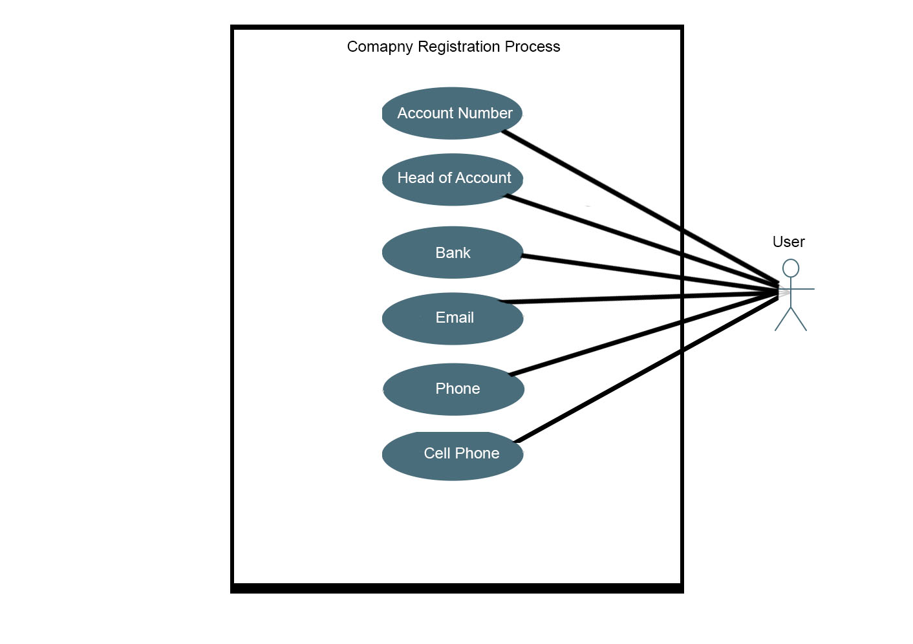

**3.1.4 Module 4 complete CRUD Image Uploading and Processing:**

***Description:*** This function will help the user to upload the image which user captures and want to sell his client to generate income.

***Usage Scenario/ Use case Description/******Specification:***

|  |  |
| --- | --- |
| Description | Image Uploading and Processing |
| Inputs | Image |
| Source | Form |
| Alternate case |  |
| Outputs | Image Uploaded on Webpage and Ready to Sell |
| Destination | None |
| Precondition | User Login |
| Post Condition |  |
| Side Effects |  |

***Detailed Use Case Diagram for Image Uploading and Processing: optional***

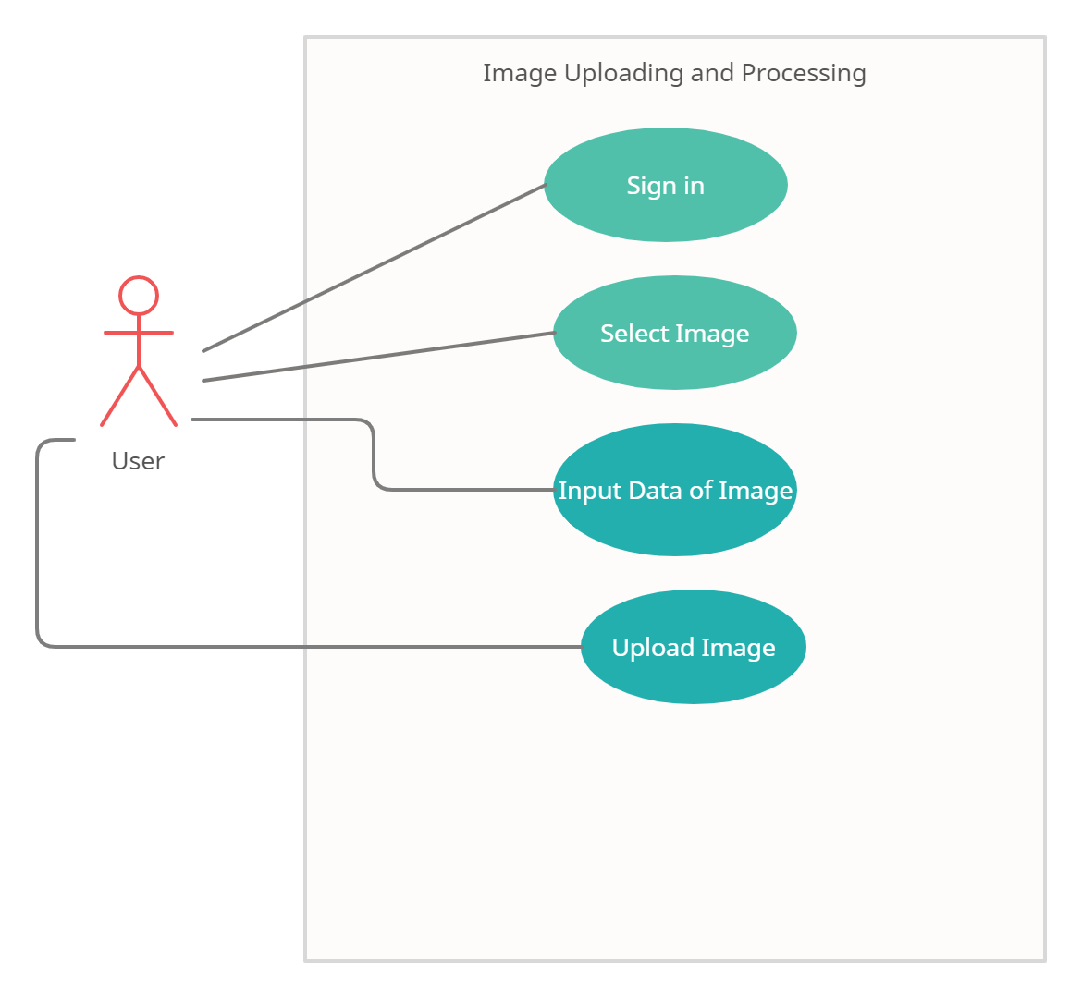

***Use case Realization for Login: optional***

***Flow of Event or Data Flow Diagram for Image Uploading and Processing: optional***

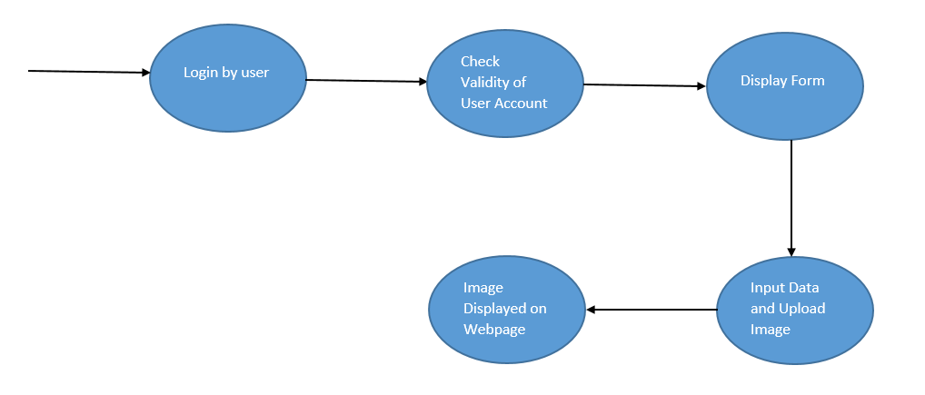

***Sequence Diagram for Login: optional***

***Collaboration Diagram for Login: optional***

***Activity Diagram for Login: optional***

***Class Diagram for Login: optional***

***State Chart Diagram for Login: optional***

**3.2. External Interface Requirements**

**3.2.1 User Interfaces**

The user interfaces are accessible for buyer and the seller through the website.

The diagrams and explanations below demonstrate the major transition from one user interface to another. This is a brief description. However, a more detailed demonstration is done in the prototype. The purpose of this interaction is to illustrate the overall view of the PB&SS.

The diagram below illustrates the four **major functionalities or modules** . These functionalities will be displayed depending on the user. For instance, the EDC will see all four functionalities while the normal user.

Login Screen:

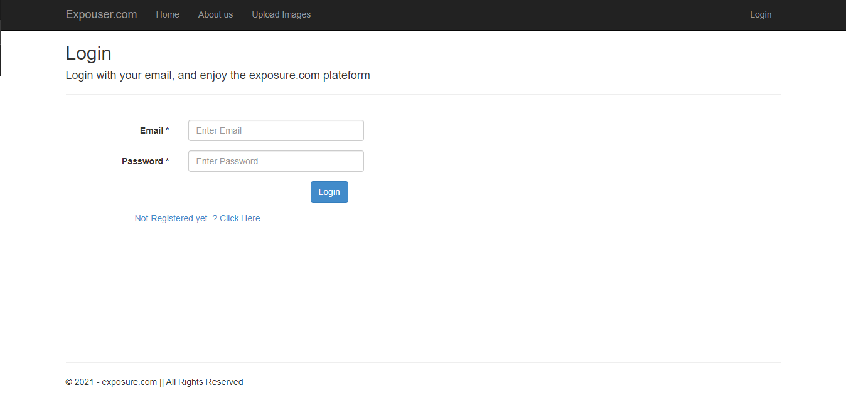

User Registration:

If the user is not registered on this application then they can create a new user with given option.

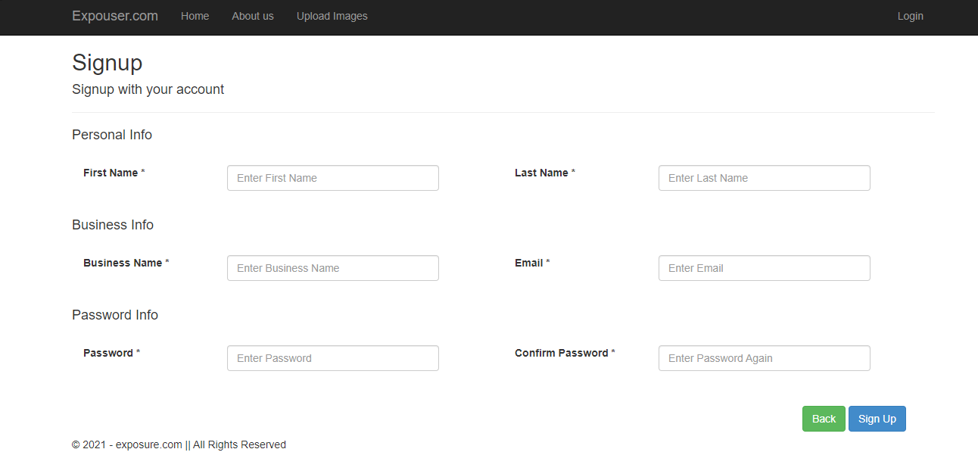

Image Upload Process:

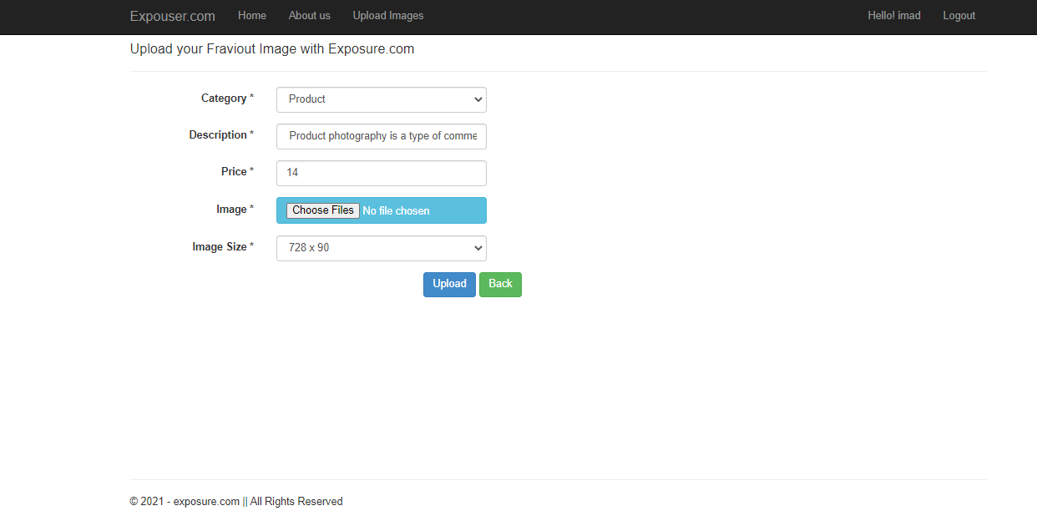

Company Registration:

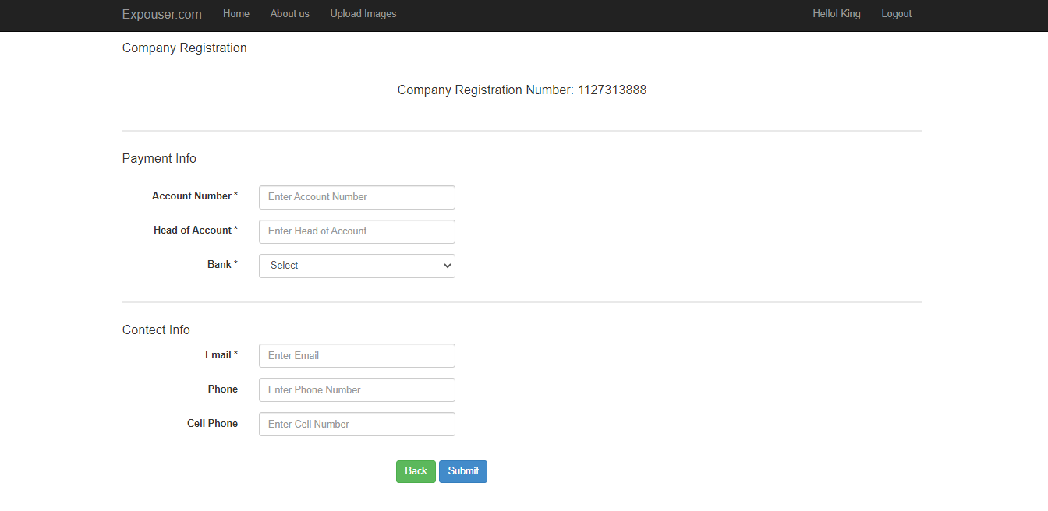

**3.2.2 Hardware Interfaces**

N/A

**3.2.3 Software Interfaces**

An SQL DBMS will be used to manage the database and any changes made to it. Furthermore, the DBMS will make regular backups of the database and generate reports regularly so that they can be accessed by the EDC.

Information about the products used for the PB&SS:

(1) Name: SQL Server

(2) Mnemonic: SQL

(3) Version Number: ?

(4) Source: Microsoft

(1) Name: Chrome Browser

(2) Mnemonic:

(3) Version Number: 94.0.4606.81

(4) Source: Microsoft

**3.3 Performance Requirements**

The following sections list the performance requirements for the system.

**3.3.1 User Requirements**

|  |  |
| --- | --- |
| User Requirements | **Description of Requirement For Design Environment** |
| Location(s) and Number(s) of Users | N/A |
| Expected Growth in Number of Users | N/A |
| After 1 Year | N/A |
| After 2 Years | N/A |
| After 3 Years | N/A |
| User Expectation | N/A |
| Interactivity | N/A |
| Reliability | For some applications, reliability must be 100% during the application session |
| Adaptability | Network must adapt to user additions, deletions and changes |
| Security | N/A |
| Cost / Funding | N/A |

**3.3.2 Application Requirements**

N/A

|  |  |  |
| --- | --- | --- |
| Categorizing  Applications | Best-Efforts | Application  Locations |
| Communication | N/A | N/A |
| Database Access | N/A | N/A |
| Database Transaction processing | N/A | N/A |

**3.3.3 Host Requirements**

|  |  |  |
| --- | --- | --- |
|  | Type of Host or  Equipment | Numbers and  Locations |
| Host A | N/A | N/A |
| Host B | N/A | N/A |
| Host C | N/A | N/A |

**3.4.1 Standards Compliance**

There are no design constraints that can be imposed by other standards limitations.

**3.4.2 Software Limitations**

∙        must be able to run Internet Explorer or Netscape Communicator web browsers to access the system.

∙        must have cell-phone web based capability to access the system from a mobile phone.

**3.4.3 Hardware Limitations**

∙        Input/Output: One or two-button mouse, keyboard, cell-phone, or touch screen required.

∙        Network card required at thin-client terminals to make communication with server possible.

**3.5 Quality Characteristics**

There are a number of quality characteristics that apply to the ARRS software system.

**3.5.1 Portability**

The ARRS system will be developed using HTML and Java so that it can be accessed from any type of system using just a regular web browser. It will also be available to users that have web access on their cellular phones. The system will be tested on all types of hardware before being released to ensure that is it compliant with this requirement.

**3.5.2 Reliability**

The system should be capable of processing a given number of reservations within a give time frame with no errors and the system should be available and operational all the time. During the development of the prototype for the 3 cities, the system will be tested in its actual environment to ensure that it can handle the load of reservations that occur during a regular workday.

**3.5.3 Usability**

The ARRS system will be developed so that it is an easy to use system that requires the least amount of user input possible. Every input will be validated. The user should only have general computer use knowledge. Error messages will be displayed if the user enters an invalid value or tries to access a function without the required permissions. An easy and well-structured user manual will be provided to the CRM and the system will include descriptive help for all operations allowed.

**3.5.4 Correctness**

The ARRS system will be considered correct when the CRM approves the prototype presented and agrees that all the functions they require are implemented as stated in the Software Requirements Specification.

**3.5.5 Flexibility**

The ARRS system should be developed in such a way that it is easily customizable. If new functions are required by CRM, there will be little effort required to update the system to support new cities or new transactions.

**3.5.6 Security**

The ARRS system should not compromise the customer information at any time. The user information will never be sold to other parties and will be kept secure at all times. Users will be authenticated to ensure that no unauthorized users gain access to private information.

**3.5.7 Maintainability**

The ARRS source code will be kept well structure and documented so that it is easier to maintain and extend the system. All changes to the system shall be documented.

**3.6 Other Requirements**

Certain requirements may, due to the nature of the software, the user organization, etc., be placed in separate categories such as those below.

**3.6.1 Data Base**

The Automate Railway Reservation System will have two main databases. One is the Reservation Database, and another is the Passenger Account Database. These databases will be created with Oracle8i (Client/Server) version 8.1.6.0.0 Release 2. The following are the requirements for these databases that are to be developed as part of the product. They include:

**Reservation Database**

|  |  |
| --- | --- |
| Types of information | N/A |
| Frequency of use | N/A |
| Accessing capabilities | N/A |
| Data element and file descriptions | N/A |
| Relationship of data elements, records and files | N/A |
| Static and dynamic organization | N/A |
| Retention requirements for data | N/A |

**Passenger Account Database**

|  |  |
| --- | --- |
| Types of information | N/A |
| Frequency of use | N/A |
| Accessing capabilities | N/A |
| Data element and file descriptions | N/A |
| Relationship of data elements, records and files | N/A |
| Static and dynamic organization | N/A |
| Retention requirements for data | N/A |

**3.6.2 Operations**

The normal operations required by the user can be viewed as the following:

User-initiated Operations:

These operations include the login operation, which is initiated by the users. Also, the process of becoming a new user is in this category. Building, changing, and viewing itineraries, as well as paying for the itinerary are all initiated by the users. The user initiates the report generation activity, as well as changing train schedules.

Interactive Operations and Unattended Operations:

The users initiate all the operations mentioned above, and almost all of them are somehow interactive. Displaying the train schedule is non-interactive. The report display is a non-interactive operation, although selecting the desired reports will require user input.

Data Processing Support Functions:

The user account data is used to create new accounts, as well as to validate user id's during login functions. For building itineraries, user input, user account data, and train schedule data are used, and processed. User data along with final results of user interaction (whether the user purchased a trip, number of tickets bought, etc.) are collected, and used for report generation purposes. Administrative users' inputs are collected in order to modify and present schedules.

Backup and Recovery Operations:

Both databases used (passenger account database and reservations database) are production databases. The main operation used for the backup and recovery is Oracle's built-in cold backup, which is also known as the "archive mode". Depending on the customer's needs and budget, additional redundancy can be added using systems like RAID 5 and tape backup.

**3.6.3 Site Adaptation Requirements**

There are no site adaptation requirements for this project.

**4. Supporting Information.**

There is no supporting information required for this project.